***FLOOD MONITORING AND EARLY WARNING SYSTEM USING RASPBERRY PI***

## **System Block Diagram**

# 

# https://i0.wp.com/electronicsworkshops.com/wp-content/uploads/2021/09/Picture2.png?resize=760%2C491&ssl=1

## ****Flowchart****

# https://i0.wp.com/electronicsworkshops.com/wp-content/uploads/2021/09/Picture3.png?resize=581%2C1024&ssl=1

## ****Hardware Description****

### ****Raspberry Pi****

### https://i0.wp.com/electronicsworkshops.com/wp-content/uploads/2021/09/Picture4.png?resize=650%2C373&ssl=1

### ****Ultrasonic Sensor****

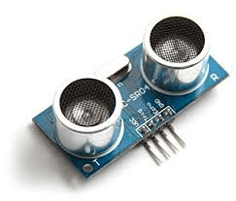

### Buzzer

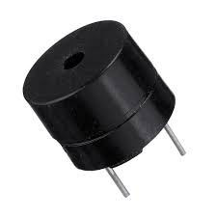

### ****Temperature and Humidity Sensors (DHT11)****

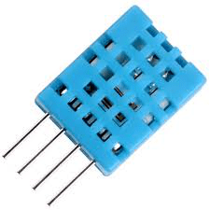

# ****DESIGN AND IMPLEMENTATION****

## ****Raspberry Pi****

# https://i0.wp.com/electronicsworkshops.com/wp-content/uploads/2021/09/Picture9.png?resize=720%2C451&ssl=1

# https://i0.wp.com/electronicsworkshops.com/wp-content/uploads/2021/09/Picture1.png?resize=880%2C528&ssl=1

### 